Problem 1

(a)

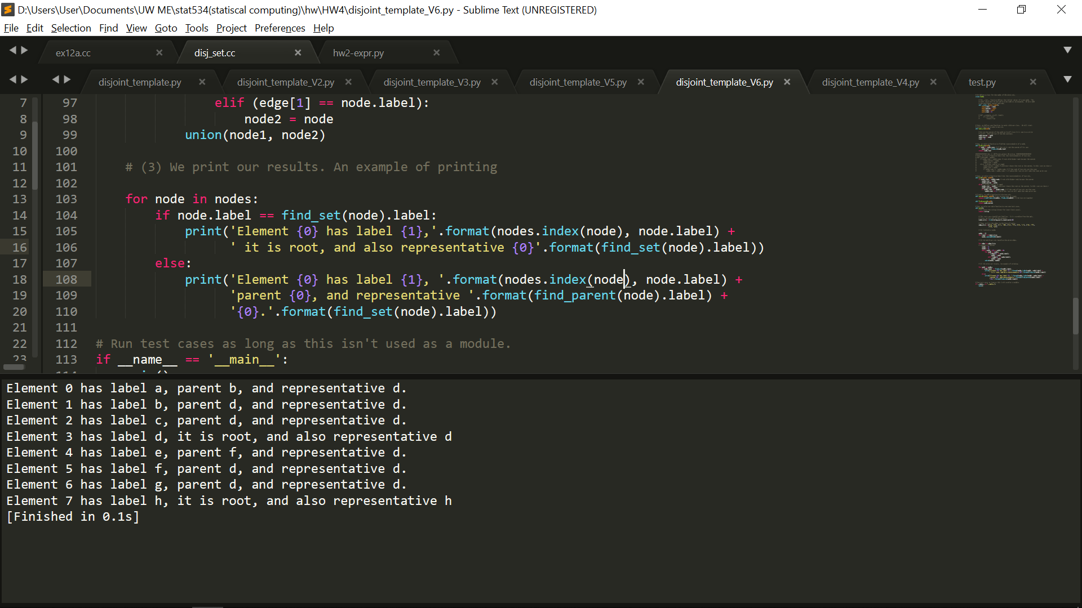

(b)

I use an array to implement the data structure. First for the initialization, I can use the Node class to create objects and I append it into nodes array. For initialize the node, I create repr for representative and parent each. This can my code to find out representative and parent separately. And my find_parent function can just return the node.parent since they are linked together. After this, I read the value from edge_list to check link the nodes. This is where I feel like my implementation is not the best runtime solution, since I have to check every element in the nodes which will take O(n) time. It could be a problem and I think the dictionary implementation is a better way since it only take O(1) compare the label from edge_list with nodes. And the rest is follow the pseudo code from the textbook.

Though it’s not the best runtime solution, it still gave me a correct answer. Definitely can be improved if I have more time, and I will try to improve it if HW5 data is too many.

Problem 2.

(a)

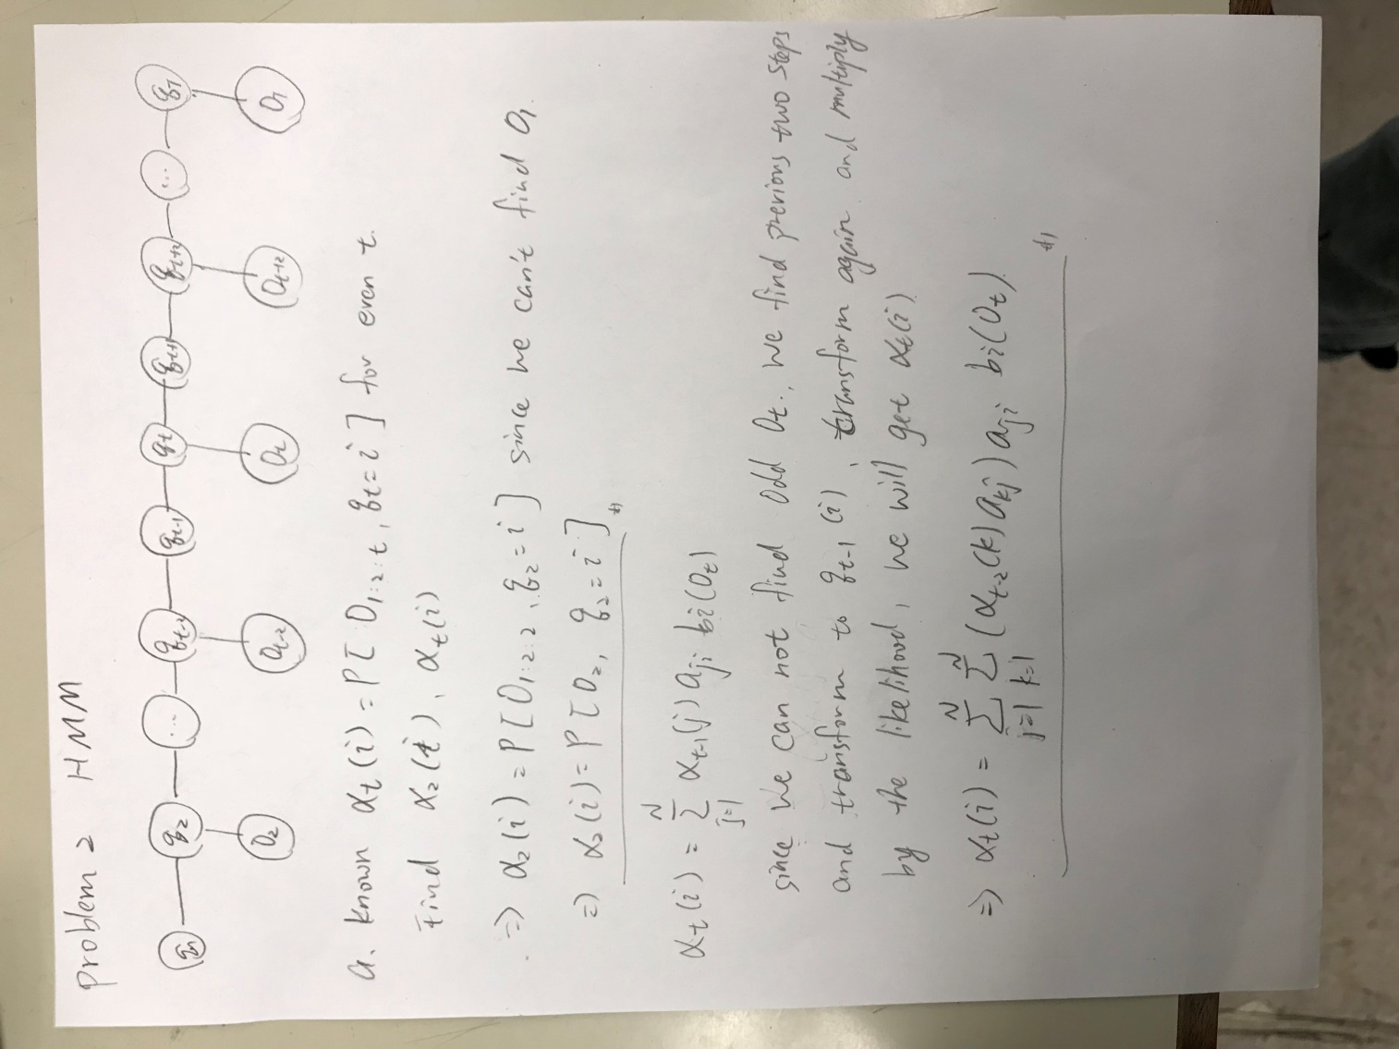

(b)

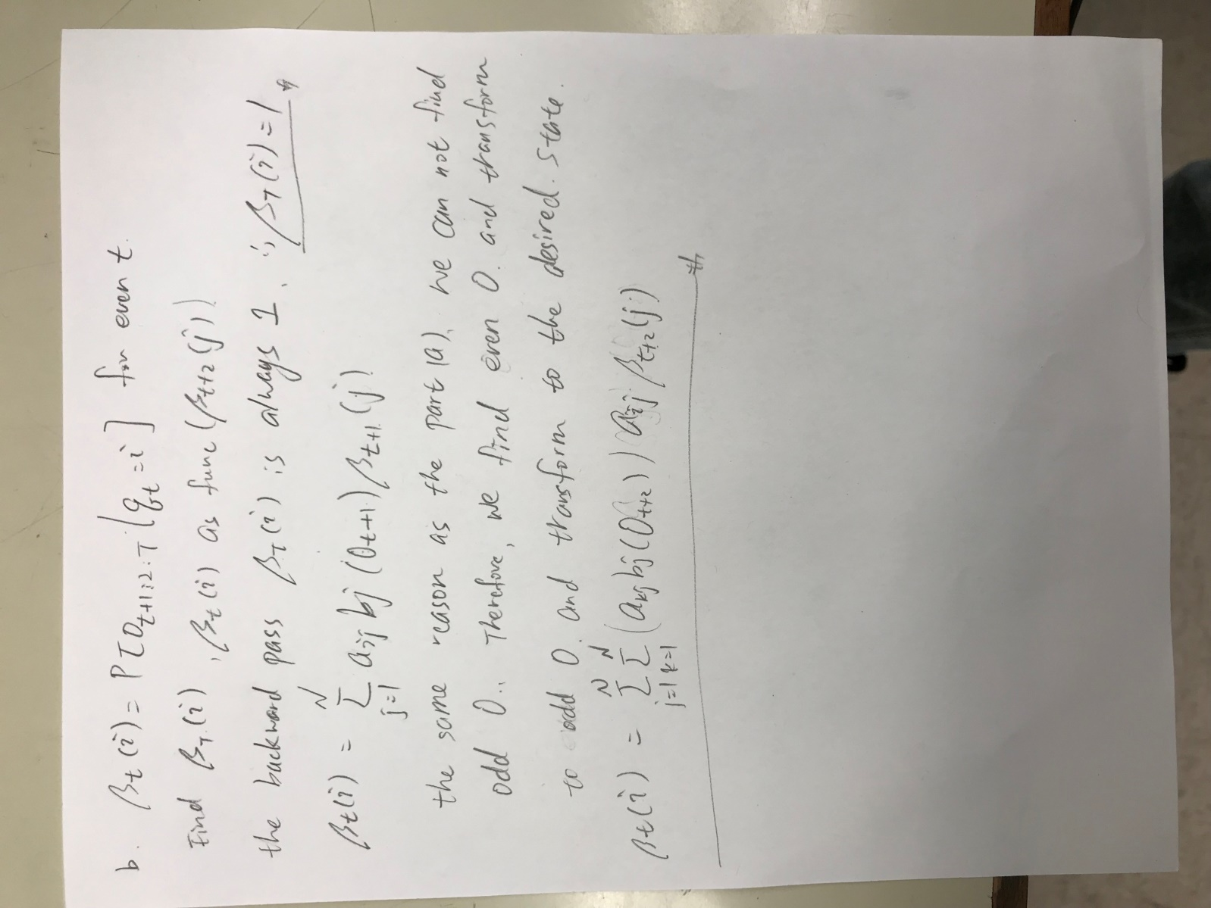

(c)

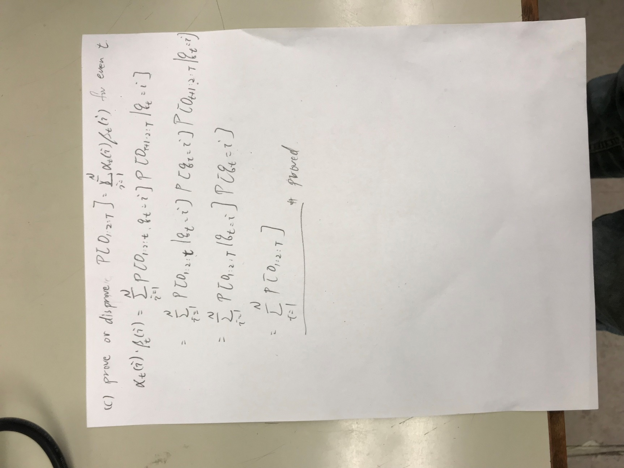

(d)

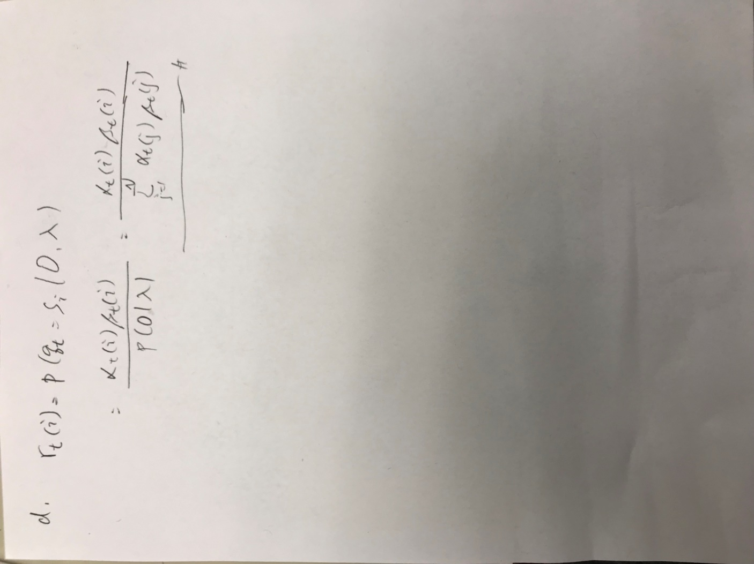

(e)

